Name: Truong Dang Truc Lam  
ID: B2111933   
Class: CT209H-M04

**LAB 3**

**EXERCISE 1: PLANNING IP ADDRESSES FOR THE NETWORK**

- IPv4 Network: 172.35.10.0/24

- Subnet Mask: 255.255.255.0

- Gateway: 172.35.10.1

- IP address for Servers: DC1, DC2, Web, VPN, DNS, DHCP, File,…

* DC1: 172.35.10.11
* DC2: 172.35.10.12
* Win 10 Workstation: 172.35.10.13
* Others: 172.35.10.14 – 172.35.10.30

- IP address for special devices: Printer, scanner, switch, routers,…

* Switch: 172.35.10.2
* Router 1: 172.35.10.3
* Router 2: 172.35.10.4
* Others: 172.35.10.5 – 172.35.10.10

- IP range for DHCP: 172.35.10.31 - 172.35.10.240

- Reservation IP:

* 172.35.10.5 – 172.35.10.10
* 172.35.10.14 – 172.35.10.30
* 172.35.10.241 - 172.35.10.254

**EXERCISE 2: MANUALLY CONFIGURING TCP/IP**

|  |  |  |  |
| --- | --- | --- | --- |
|  | DC1 | DC2 | Win 10 Workstation |
| IP Address | 172.35.10.11 | 172.35.10.12 | 172.35.10.13 |
| Subnet Mask | 255.255.255.0 | 255.255.255.0 | 255.255.255.0 |
| Preferred DNS Server | 172.35.10.11 | 172.35.10.12 | 172.35.10.11 |

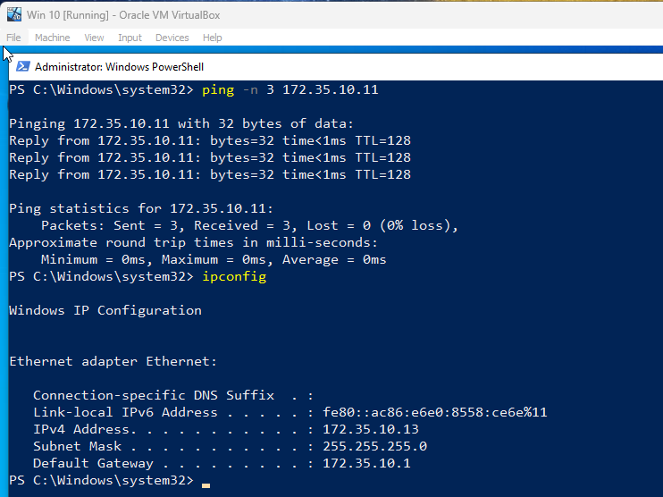

Test connectivity between DC1 and Win 10 Workstation

**EXERCISE 3: INSTALLING DHCP SERVER ROLE**

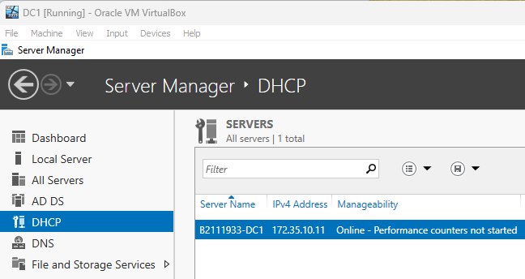

DHCP installed

**EXERCISE 4: CREATING A DHCPV4 SCOPE**

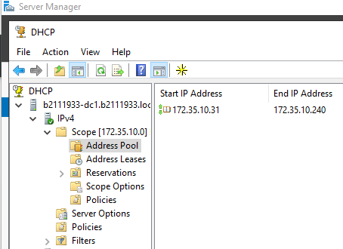

Create DHCPV4 Scope

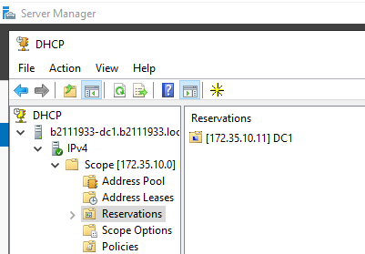

Add DC1 as Reservation (just for practice, IPv4 of DC1 is not in DHCP Scope)

**Challenge:**

**- Confirming that DHCP work: demonstrate that a computer can automatically obtain IP from DHCP.**

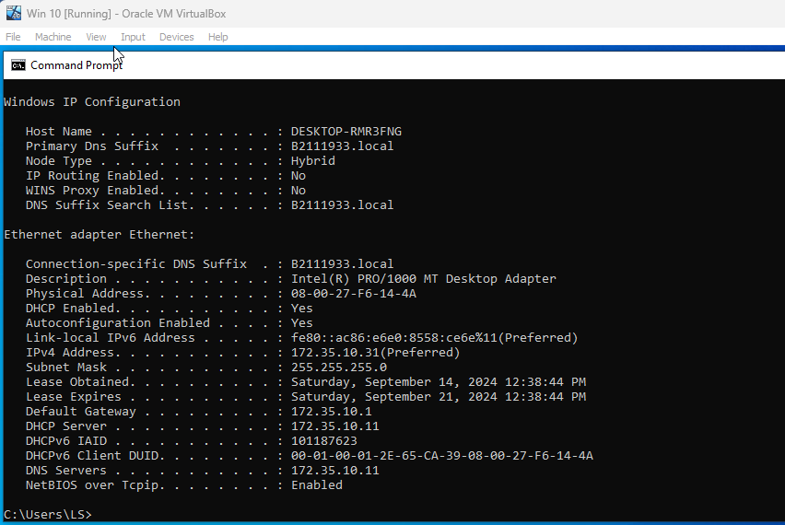

A Windows 10 VM can automatically obtain IP from DHCP

**- Creating a DHCPv6 Scope**

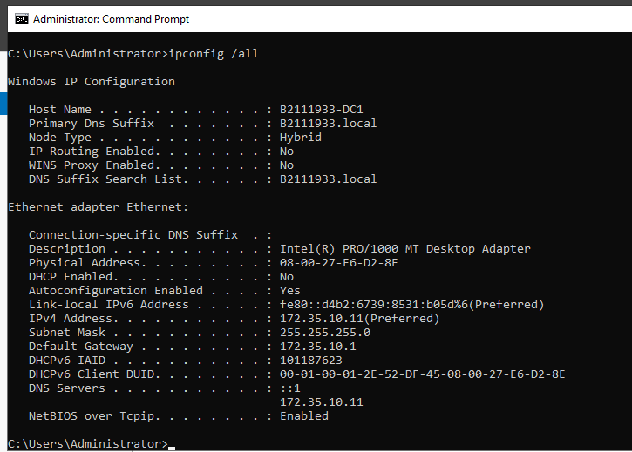

Ipv6 of DC1

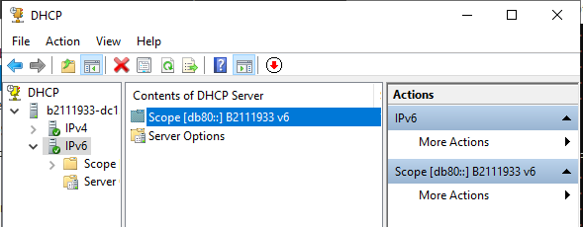

Create a DHCPv6 Scope

**- What is DHCP superscope? Installing and configuring a superscope**

A DHCP superscope is a collection of individual scopes that are grouped together for administrative purposes. It allows a DHCP server to provide leases from more than one scope to clients on a single physical network, making it useful in multinet configurations where multiple logical networks exist on a single physical network. Superscopes simplify management, improve scalability, and offer increased flexibility in IP address allocation.

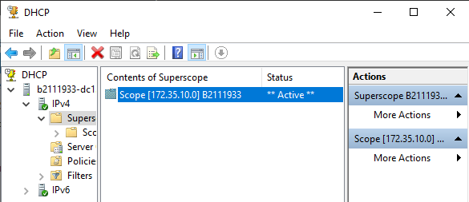

Install and configure a superscope

**- What is DHCP Relay agent?**

DHCP Relay Agent is a network device that acts as a middleman between DHCP clients (like computers, smartphones, and tablets) and DHCP servers. When a client needs an IP address, it sends a DHCP Discover message to the relay agent. The relay agent then forwards the message to the DHCP server. Once the server assigns an IP address, it sends it back to the relay agent, which then passes it on to the client. This process ensures that clients can obtain IP addresses even when they are physically distant from the DHCP server.

**EXERCISE 5: INSTALL AND CONFIGURE DNS SERVERS**

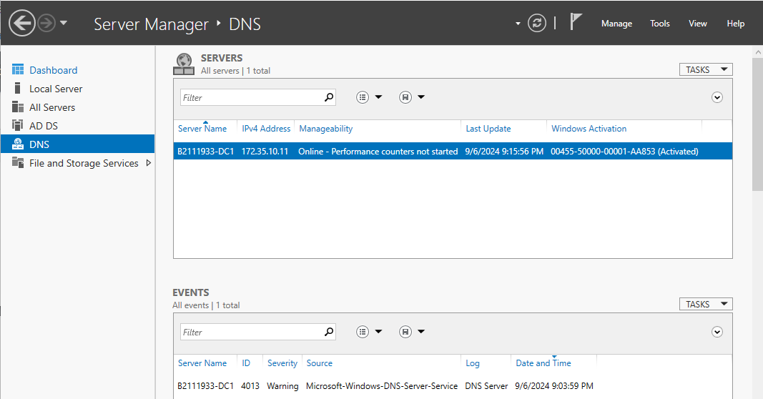

Install DNS server

**EXERCISE 6: CONFIGURE FORWARDERS, ROOT HINTS, AND RECURSION**

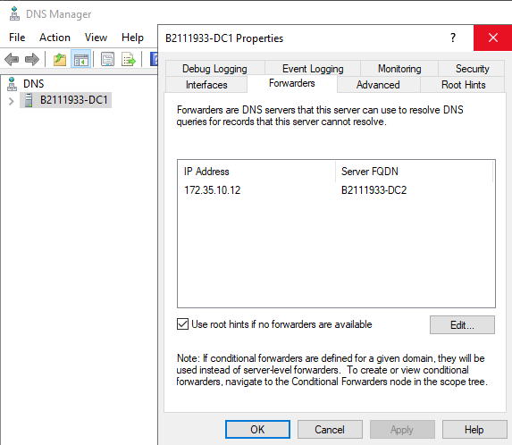

Add the IP Address of DC2 as forwarder

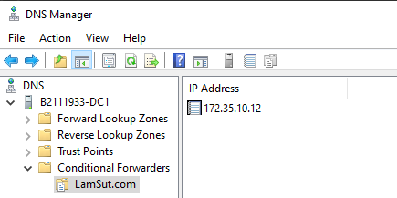

Configure conditional forwarding

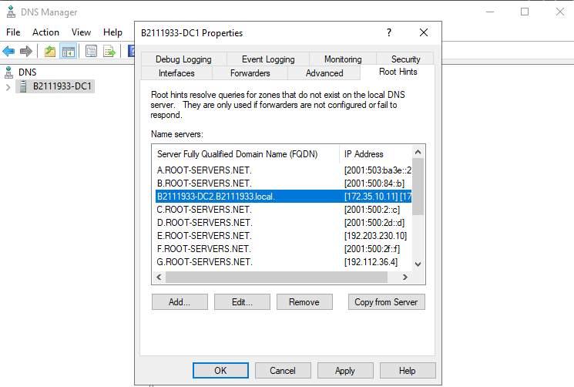

Edit root hints

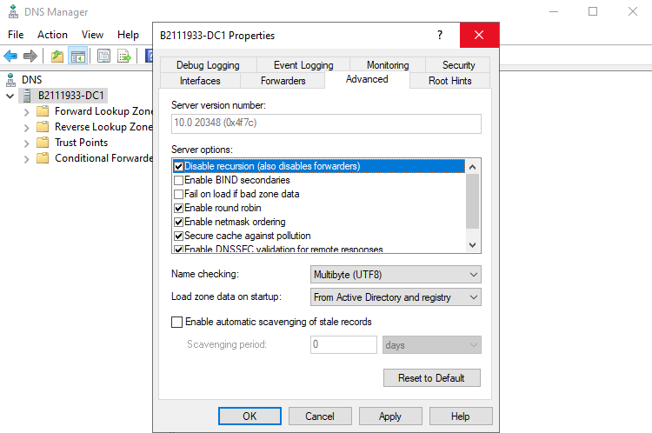

Disable recursion in DNS can enhance the security aspect   
(limit the potential for our DNS server to be used for malicious activities like DDoS attacks).

**EXERCISE 7: CREATE AND CONFIGURE DNS ZONES AND RECORDS**

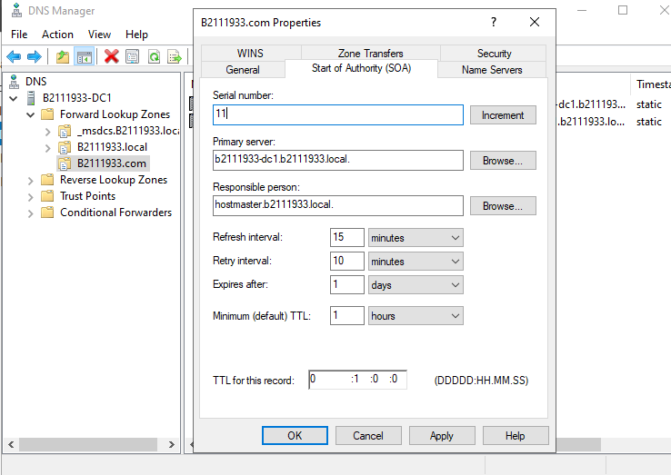

Create a primary zone and reconfigure the SOA record

**EXERCISE 8. CREATING DNS RESOURCE RECORDS**

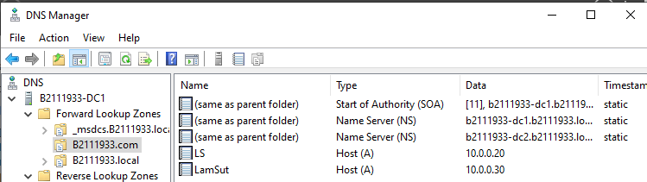

Create DNS resource records

Challenges: Configure the DNS server to perform reverse name resolutions for all of the resource records you created in previous exercise. List the basic tasks you performed to complete the challenge and then take a screen shot of the DNS Manager console.

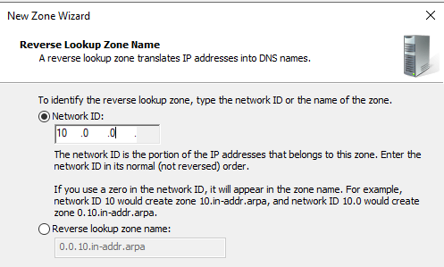

Create a reverse lookup zone

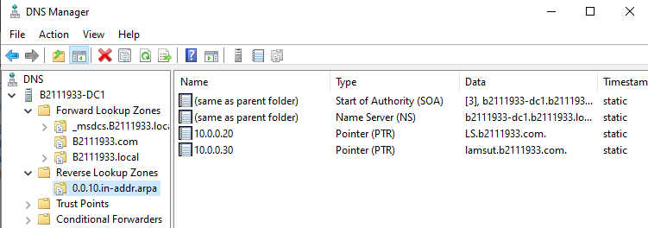

It will perform reverse name resolutions for all of the resource records we have created